Final Project Proposal

Yuqing Nan

Topic

For my final project, I would like to build a website that introduces some famous places in Shenzhen for not only travelers but also local people. Tourism has become one of the biggest and fastest-growing industries in China. According to the Minister of Culture and Tourism of the People’s Republic of China, during the National Day holiday, the country received a total of 618 million domestic tourists and achieved tourism revenue of 454.33 billion yuan.

Problem Statement

Based on the research, in order to plan a “perfect” trip, the users usually need to seek information from more than twenty travel websites, travel blogs, or travel articles. Which wastes plenty of time on plan a trip that can meet the needs of users. My website plans to provide every detailed information and suggestions for each place. By identifying the categories of each place, the users can plan their unique trip based on their interests.

Pain Points

Here are two listed pain points that I would like to solve in my website:

* Vague or incomplete introduction of places: users need to gather detail information from several websites
* Not updated information on other websites: in my website, I will keep updating the information for each place
* Figuring out the right places for users: different people have diverse interests and habits

Customer Journey Map

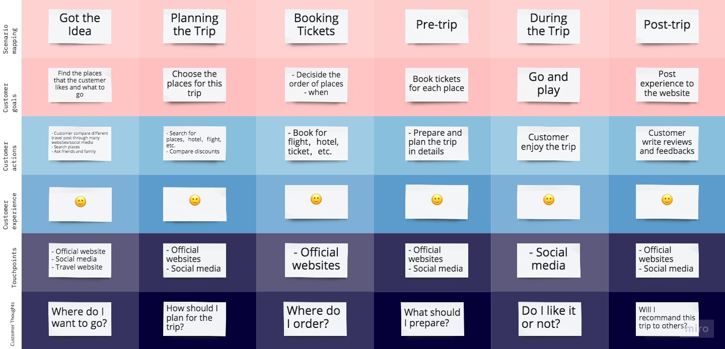

Dataflow Diagram

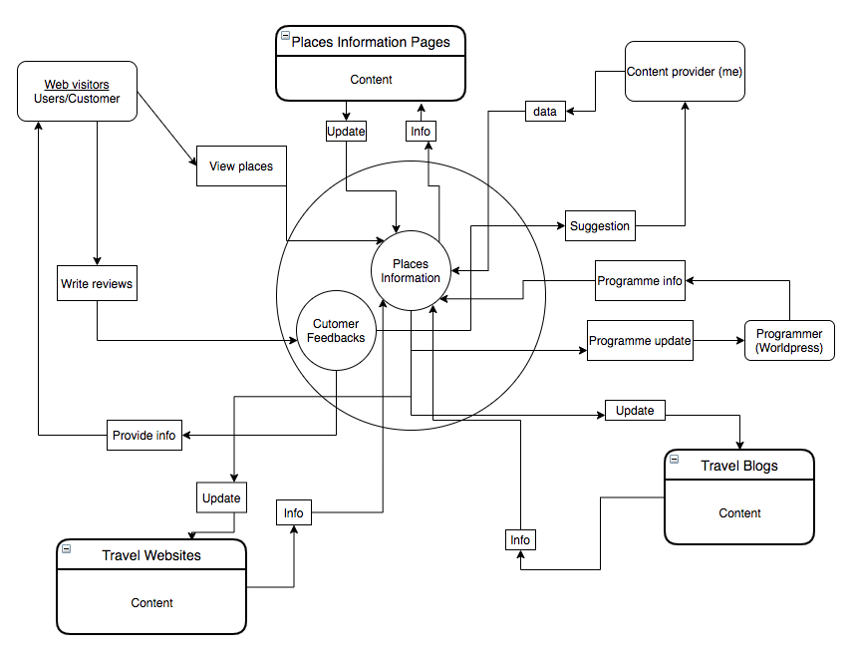

Entity-relationship Diagram

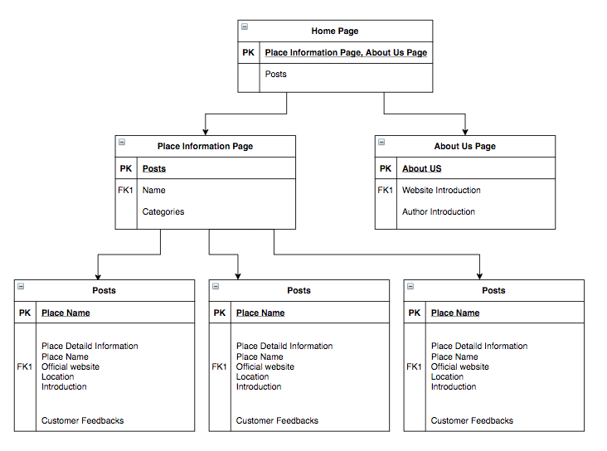

The dataflow diagram will explain the key data views.

The entity relationship diagram with explain the information structure which is hybrid structure.